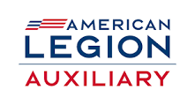
National Security Awareness Luncheon
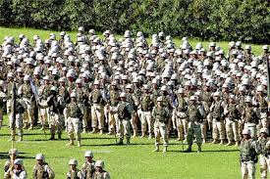
February 17, 2024 11am-2pm
American Legion Post 17
21 Cedar St
Naugatuck CT
$15.00 per person
Soups, Salad, Sandwich and Dessert
Guest speakers, amazing program information and Legion Family time…what a great way to spend a day!
Reservation deadline February 8, 2024
Send reservation form and check to:
ALA, Dept of CT, PO Box 266, Rocky Hill, CT 06067-0266
-------------------------------------------------------------------Name:______________________________________________________________
Unit/Post:_______________ Number attending:___________
Total Enclosed:__________
If more than one attending, please include the list of attendees names.

